CLOUD COMPUTING



# Introduction

Cloud computing is the delivery of on-demand computing services over the internet on pay-as-you-go basis.

Rather than managing files on a local storage device, cloud computing makes it possible to save them over internet.

There is various cloud computing service provider such as AWS (Amazon Web Services), Microsoft Azure, IBM Softlayer, etc.

# Purpose of Cloud Computing

Why we should use cloud computing services because it is better than on-premise service. In on-premise service we have to pay more, compare to the amount of services we use. Whereas in cloud computing, we pay for what we use. It depends on amount of services we use. If we use more services we have to pay more services we have to pay more and if we use fewer amounts of services we have to pay less. In on-premise service, huge space is required to install servers, whereas in cloud computing services, no space is required as everything is virtual. For on-premise service, we have to appoint a team for hardware and software maintenance, whereas in cloud computing, no experts are required for the maintenance. On-premise service has poor data security and cloud computing has better data security. There is lack of flexibility in on-premise service, whereas cloud computing service provides high flexibility. There are no automatic updates in on-premise service, but the software in cloud computing are automatically updated. Data cannot be accessed remotely in on- premise service, but in cloud computing, data can be accessed and share anywhere over the internet. On-premise service takes longer implementation time, whereas there is rapid implementation in cloud computing.

# Types of Cloud Computing

Cloud computing consists of two types

Deployment Model

Service Model

## Deployment Model

It consists of three more types Public Cloud, Private Cloud and Hybrid Cloud

**Public Cloud**

This type of cloud infrastructure is made available to the general public over internet and is owned by a cloud service provider. Eg. Microsoft Azure, IBM’s Blue Cloud and Sun Cloud.

**Private Cloud**

This type of cloud infrastructure is exclusively operated b a single organization. It can be managed by the organization or a third party and may exist on premise or off premise. Eg. AWS, VM Ware.

**Hybrid Cloud**

His type of cloud infrastructure consists the functionalities of both public and private cloud. Eg. Federal agencies opt for private clouds when sensitive information is involved. Also, they use public cloud to share datasets with general public or other government departments.

Service Model

1. Iaas-Infrastructure as a Service
2. Paas-Platform as a Service
3. Saas-Software as a Service

Iaas

If there is need of virtual machines into the business, user opts for infrastructure as a service.

Pass

If company needs platform from building software products, user picks Platform as a Service.

Saas

If user doesn’t want to maintain any IT equipment, then they choose Software as a Service.

# Cloud Providers

There are various cloud providers like AWS, Microsoft Azure, IBM Cloud, VM Ware, Google Cloud Platform, Digital Ocean, etc.

Now let us do the comparative study of AWS (Amazon Web Services) and Microsoft Azure. First we have to study about both the cloud computing services individually.

AWS



# Introduction

Amazon Web Services is the subsidiary of Amazon.com that provides on demand cloud computing platforms to individuals, companies and governments, on a paid subscription basis with a free-tier option available. It was launched in 2006 and it has pay-as-you-go system. AWS is the leading cloud computing service provider with highest no. of companies using its services. AWS helps in controlling, auditing and managing identity configuration and usage and it offers nearly 100 cloud applications with features. AWS has global infrastructure of 18 geographic regions with 50 availability zones.

# Services Provided

The most commonly used services of AWS are,

1. Amazon EC2
2. Amazon Elastic Beanstalk
3. Amazon Lightsail
4. Amazon Lambda

## Amazon EC2

Amazon EC2 provides compute capacity in the cloud. This capacity is secure and resizable based on the user’s requirement.

## Amazon Elastic Beanstalk

This helps to scale and deploy web applications made with a number of programming languages.

## Amazon Lightsail

It enables a Virtual Private Server to be launched and managed with ease.

## Amazon Lambda

Allows us to pay only for computing time. There is no need for provisioning and managing servers.

More storage services of AWS are,

1. Amazon S3
2. Amazon Glacier
3. Amazon EBS
4. Amazon Elastic File System

## Amazon S3

Amazon S3 is an object storage that can store and retrieve data from anywhere. Websites mobile apps, Iot sensors and so no.

## Amazon Glacier

Amazon Glacier is a cloud storage service that is used for archiving data and long term backup.

## Amazon EBS

Amazon Elastic Block Store provides block storage volumes for the instances of Amazon EC2.

## Amazon Elastic File System

Amazon EFS provides elastic file storage which can be used with AWS cloud services and resources that are on premise.

Some more services of AWS are,

1. AWS Application Discovery Service
2. Amazon Route S3
3. Elastic Load Balancing
4. AWS Auto Scaling
5. AWS Identity and Access Management

## AWS ADS

It helps enterprise customers perform the process of migration by collecting information about their on-premise data centers.

## Amazon Route S3

Route S3 is a scalable DNS web service. It is a way to route end users to internet applications.

## Elastic Load Balancing

Elastic Load Balancing automatically diverts the incoming traffic into multiple targets.

## AWS Auto Scaling

AWS Auto Scaling automatically adjusts resource usage to ensure steady performance at the lowest cost.

## AWS Identity and Access management

AWS IAM helps user manage AWS resources securely. It allows users and groups to be allowed or denied permission.

# Advantages

## Security

AWS provides a secure and durable platform which provides end to end privacy and end to end security and storage.

## Experience

User has benefit from AWS due to its skills and infrastructure management due to its years of experience.

## Flexibility

AWS allows the user to select the OS, language, database and other services.

## Easy to Use

We can host our applications quickly and securely on AWS whether it’s an existing or new one.

## Scalability

The application can be easily scaled up or down depending on user’s requirement due to AWS.

## Cost Saving

In AWS, we can only pay for the compute power, storage and other resources we use without any long-term commitments.

MICROSOFT AZURE

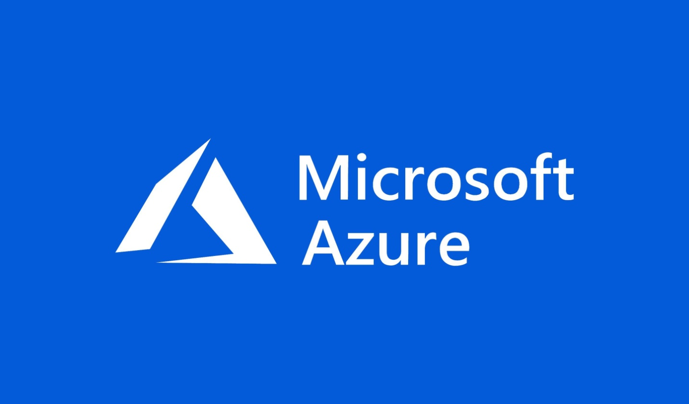

# Introduction

Microsoft Azure is a cloud computing platform and an online portal to access and manage resources and services provided by Microsoft. It was launched on 1st Feb 2010 and it is free to start and it provides pay-per-use model. There are 80% of fortune 500 companies who use Azure services. Azure supports multiple programming languages like C#, Node.Js, JavaScript, etc. azure has datacenters in 42 regions around the world.

# Azure Services

Their services are divided into 18 categories and contain more than 200 services.

Compute, Networking, Storage, Iot, Migration, Mobile, Analytics, Containers, AI+Machine learning, Integration, Management Tools, Developer Tools, Security, Databasis, DevOp, Media, Identity and Web.

We are going to study about its main services,

1. Compute Services
2. Networking Services
3. Storage Services
4. Functions

## Compute Services

### Virtual Services

This service creates windows or Linux virtual machines of any configurations in a matter of seconds.

### Cloud Services

In this service, users can create, scalable applications within the cloud using the virtual machines whose provisioning, load balancing and health monitoring are handled by Azure post-deployment.

### Service Fabric

Service fabric simplifies micro service deployment and application lifecycle management.

### Functions

This service easily builds applications using server less functions in any programming language of the user’s choice.

## Networking services

## Azure CDN

Azure CDN services are used for delivering high individuals content to users worldwide.

## Express route

Express route lets on-premise networks into Microsoft cloud through a private connection.

## Virtual network

Virtual network enables Azure resources to securely communicate to each other.

## Azure DNS

Azure DNS is a holding service that allows the user to host their DNS domain in Azure.

## Storage Services

### Disk Storage

Azure provides cost-effective HDD/SDD options which can be used with Azure Virtual Machines.

### Blob Storage

Blob storage is optimized for storing massive amount infrastructure data, such as text user or binary data.

### File Storage

AWS manage file storage in the cloud that is accessible via industry standard server message block (SMB) protocol.

### Queue Storage

Queue storage provides durable message queuing for large workloads and can be accessed from anywhere in the world.

## Advantages

1. Application development
2. Testing
3. Application hosting
4. Creating virtual machines
5. Integrating and syncing features
6. Collecting and storing metrics
7. Virtual hard-drives(VHD)

AWS V/S AZURE

# Introduction

## AWS

AWS was launched in 2006 and is used by majority of companies around the world. AWS dominates the cloud computing domain with 40% of market share. AWS provides a wide range of services covering a wide range of domain.

## Azure

Azure was launched in 2010 and is used by most fortune 500 companies in the world. Azure provides services to more regions than any other cloud services in the market. Azure provides more than 100 services covering a wide variety of domains.

# Current Performance

40% of the organizations in the market share, show clear interest in using AWS. AWS is number one, because of their years of experience and trust they have created among the users. Azure is also not very far behind; more than 80% of the Fortune companies’ trust Azure is also not very far behind, more than 80% of the Fortune companies trust Azure with their cloud computing needs. The rest of the 30% represents other cloud platform providers like Google Cloud Platform, Rackspace IBM Softlayer, etc.

# Pricing Comparison

|  |  |
| --- | --- |
| AWS AWS provides 2 CPU’s and 8 GB RAM for 0.0928$ USD/hour. | AZURE Azure provides 2 CPU’s and 8GB RAM for 0.096$ USD/hour. |

# Market Share

|  |  |
| --- | --- |
| AWS AWS occupies 40% of the market share of the cloud computing domain and it is the obvious market leader. It also provides itself in having more than 100 services that span of over 15 domains and are most commonly used across the world. | AZURE Azure is having 30% of market share. More companies are moving towards Azure, it is likely to overcome AWS. It also provides a constantly improving roster with more than 100 services spanning a wide range of services. |

# Instance Configuration

|  |  |
| --- | --- |
| AWS The largest instance that AWS offers is 256 GB RAM and 16 virtual PC’s. | AZURE The largest instance that Azure offers is 224 GB RAM and 16 virtual CPU’s. |

### 